Question 1 – UML State Machine Diagram – Smart Washing Machine
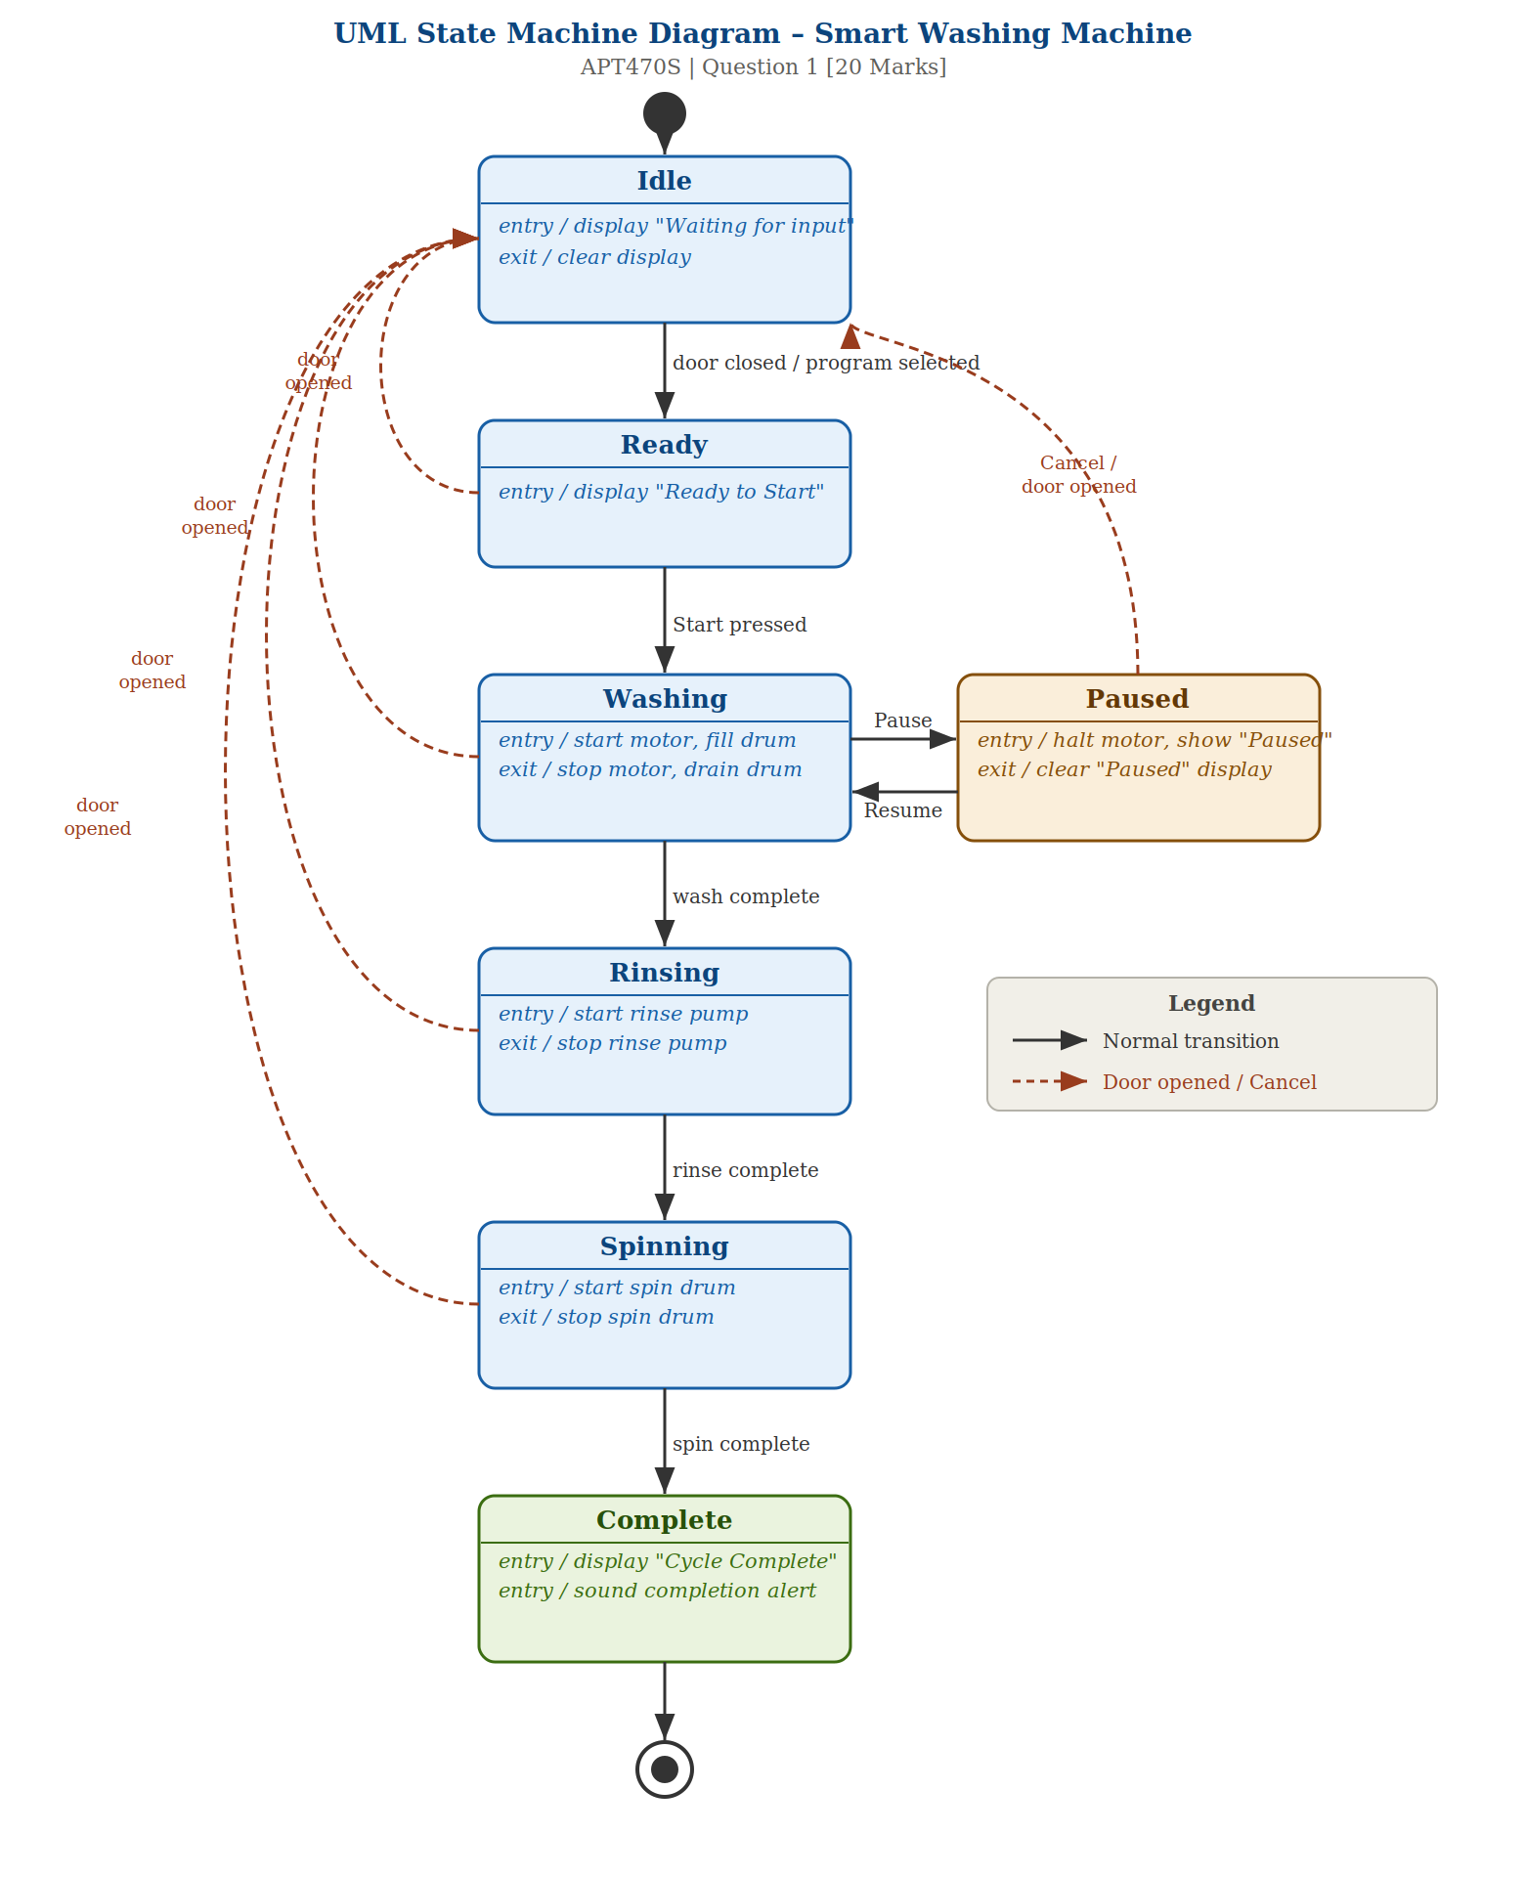

Explanation of the UML State Machine
Idle Ready Washing Paused Rinsing Spinning Complete
The machine has seven states along with an initial pseudostate (filled circle) and a final pseudostate (bullseye).
States: The machine has seven states Idle, Ready, Washing, Paused, Rinsing, Spinning, and Complete along with an initial pseudostate (filled circle) and a final pseudostate (bullseye).
Entry/Exit Actions: Each state includes relevant entry and/or exit actions. For example, the Washing state starts the motor and fills the drum on entry, and stops the motor and drains the drum on exit.
Door Opened Transitions: From any state prior to Complete (Ready, Washing, Paused, Rinsing, Spinning), opening the door returns the machine to Idle. These are shown as dashed coral arrows on the left side of the diagram.
Pause/Resume: Washing transitions to Paused on the Pause trigger, and returns to Washing on Resume. Cancel from Paused also routes back to Idle.

Question 2

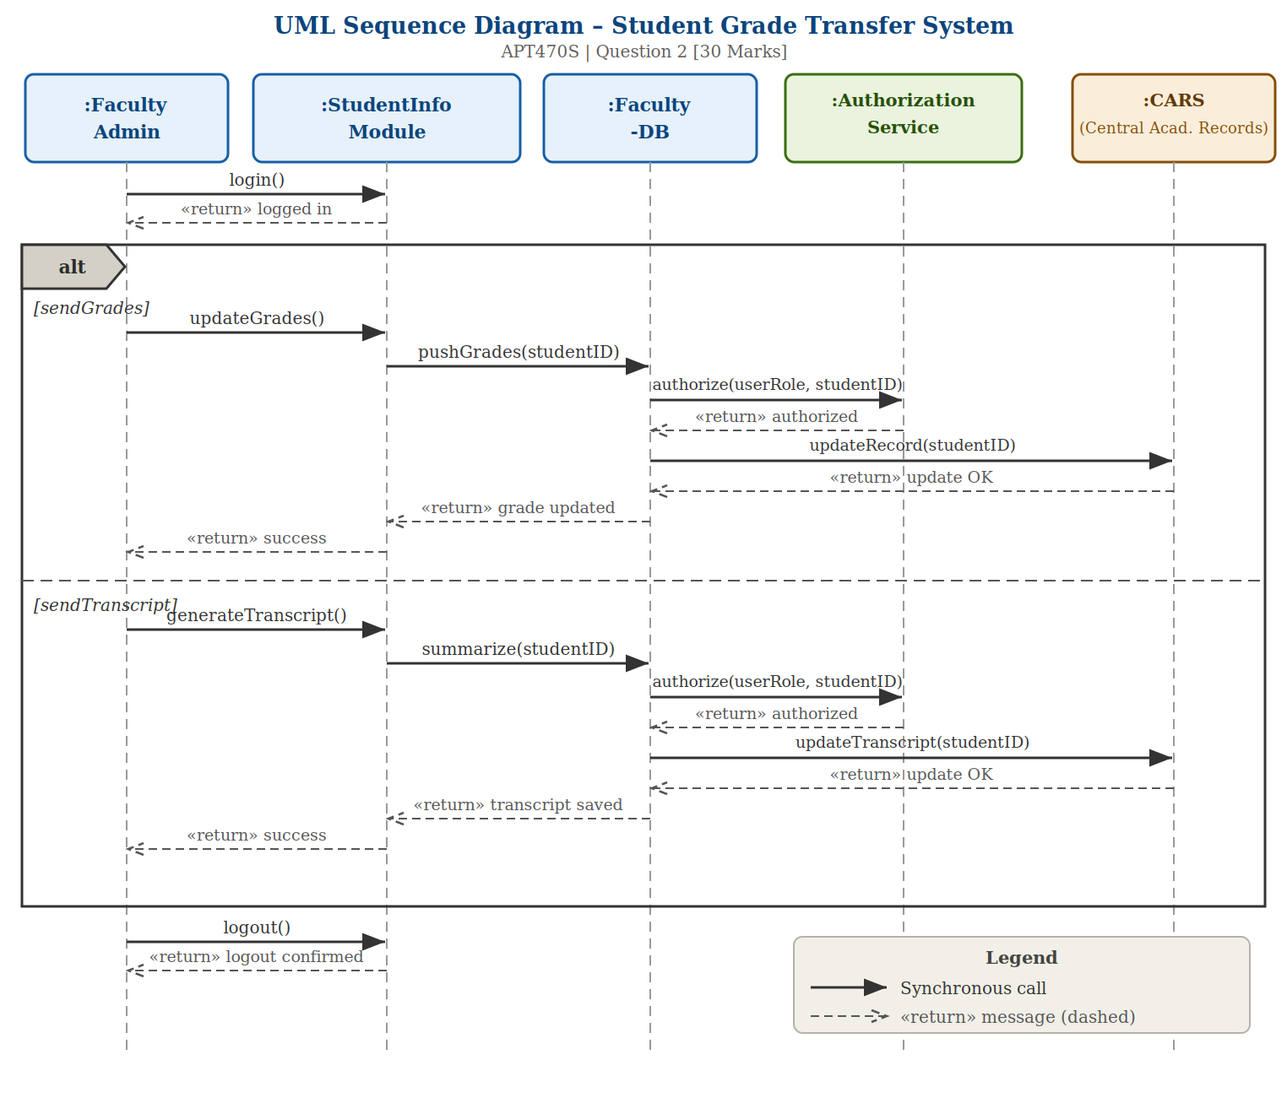
Explanation of the UML Sequence Diagram
Lifelines: Five lifelines are shown :Faculty Admin, :StudentInfo Module, :Faculty-DB, :Authorization Service, and :CARS each represented by a dashed vertical line below their header box.
Login/Logout: login() and logout() calls appear outside the alt fragment as they are unconditional steps for every interaction.
Alt Fragment: The alt combined fragment (shown with the pentagon 'alt' label at the top-left) contains two guard-separated paths: [sendGrades] and [sendTranscript], divided by a dashed horizontal line.
Authorization: Both paths include an identical authorization sub-flow where Faculty-DB calls authorize(userRole, studentID) on the Authorization Service before writing to CARS.
Return Messages: All return messages are shown as dashed arrows labeled with the return value (e.g., 'update OK', 'authorized', 'success'), following UML sequence diagram conventions

